DATE : 26/02/2026
S3 BUCKETS
1.CREATE A BUCKET
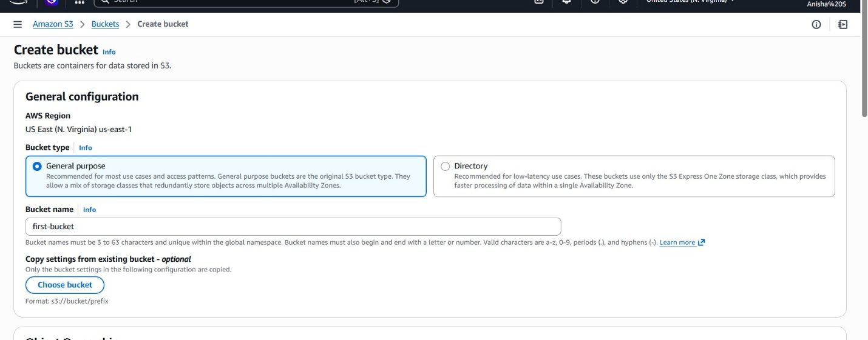
2.

